**CONCEPTS OF ETHICAL HACKING LAB**

**WEEK – 6**

**Study of Web based Password Capturing Technique**

Demonstrating web-based password capturing technique using Wireshark which is network protocol capturing and analysing tool. It captures any web-based protocol coming and going from the host machine and analyse it.

**Requirements:**

1. Wireshark/Burp Suit.
2. A http-based login page.

**Procedure:**

1. Download Burp Suit/ Wireshark and install it.
2. Open the Wireshark and select the network (i.e., Ethernet/wi-fi) over which the internet is connected to start capturing the network protocols and if anyone is hosting the login page in localhost then select the loopback interface.
3. 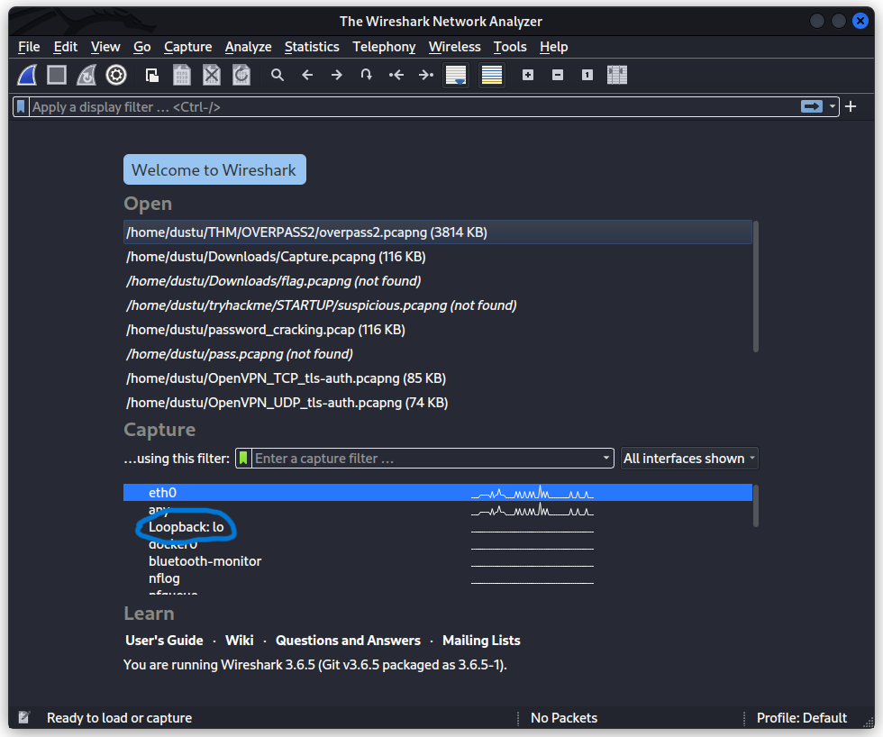
4. Or Open the Burp Suit and if first, setup proxy (Go through any guide on the internet) in the browser and make sure intercept is turned on in the Proxy Tab.
5. Graphical user interface, application

   Description automatically generated
6. Open the browser and go to the http login page.
7. Enter the credentials.
8. Graphical user interface, application, Teams

   Description automatically generated
9. Now stop capturing the network protocols in the Wireshark or stop the intercept in the Burp suit.
10. Analyse the intercepted protocols in Wireshark/Burp Suit and retrieve the credentials and in case of in case of Wireshark various filters can be applied to narrow down the search field.
11. Burp suit:Graphical user interface, text, application

    Description automatically generated
12. Wireshark:Graphical user interface, text, application

    Description automatically generated
13. Graphical user interface, text

    Description automatically generated

----END---